Dear Parent and Carers,
As promised, I am writing with additional information about the return of students to our school. campus. First, a reminder about the dates for our phased return.
Commencing 25 October  (Week 4) | - Early childhood centres (ECEC)  - Preschool and kindergarten  - Years 1 and 2  - Year 6  - Years 9 and 10  - Out of school hours care (OSHC)
Commencing 1 November  (Week 5) | - Years 3, 4 and 5  - Years 7 and 8
From weeks 1 to 4 of term, onsite supervision and care continues to be available for vulnerable children and young people whose parents are essential workers.

Drawing on national and local health advice we have developed a return to school plan which has three key priorities:
- the health and safety of staff and young people,
- the mental and emotional well-being of students and staff, and
- ensuring continuity of learning.
Below is an outline of ACT Health Guidelines that schools are required to implement to ensure effective COVID-19 measures are in place.
Use of Check in CBR app | All staff and visitors must check in using the ‘Check in CBR' app. Parents and carers cannot enter school grounds except for an essential reason. Visitors must call to make an appointment, or in advance of attendance. All visitors must report to the front office.
Student illness | Staff and students who are unwell are not able to attend school. Students who present unwell will be required to go home.
Hygiene | Schools will maintain and promote appropriate hand hygiene and respiratory hygiene practices. Students will need to wash hands and use hand sanitisers throughout the day. Students will not be allowed to share food or drink.

Masks | Staff, visitors and students* in years 7-12 must wear a face mask on campus. Students in years 3-6 are encouraged to wear a mask if they are comfortable doing so. Students in Preschool to year 2 are not required to wear a mask. Masks may not be suitable for students with a disability or medical condition and schools will make allowances for those students not to wear masks.  * Students will be required to wear their personal masks. Masks will be available at school for those who require them. Disposable masks need to be changed every four hours.
Physical Distancing | Physical distancing between children and young people is not always possible, particularly in single classrooms and school environments. It is however important for limiting the transmission of COVID 19. To promote physical distancing we may adjust learning programs, breaktimes, our timetable as well as pick up and drop off arrangements. More specific information about what this means for your child is included below.
Environmental cleaning | Our school cleaning program includes regular cleaning of high touch services, frequently used objects, and play equipment.
Ventilation | All schools have been assessed to increase fresh air circulation and this may involve changes to ventilation, modified HVAC system settings and maximising the use of outdoor learning spaces.
Managing suspected cases | We are prepared to respond to a positive COVID-19 case on campus, should the need arise. ACT Health will provide direction to the school and community, which may result in a full or partial school closure. A student who presents with symptoms of COVID-19 will be isolated with suitable supervision, and parents will be required to collect their child. Symptomatic students will be required to wear a mask.
Will schools have routine testing for COVID-19? | Anyone with COVID-19 symptoms should get tested immediately. ACT Health is not recommending routine COVID-19 testing of children, young people  or staff using rapid antigen testing.
Wellbeing supports | Wellbeing and learning supports, such as face to face appointments with the school psychologist or access to a Learning Support Assistant, will recommence with the return to school.  For parents and carers of students with a medical vulnerability: if you wish the school to make reasonable adjustments for the safe return of your child, you must consult a GP and provide medical advice to that effect. Where adjustments can’t be made, the school will support your child to learn from home.

To further support the ACT Health Guidelines our school is making the following adjustments.
Drop off and pick up | The drop off and pick up of students can occur in 2 places. At the front of the school there is a designated area marked as Pick up and Set down Only. This area will operate for all families who are able to drop their child/ children at school from 8:45am and pick up from 3:00pm without leaving their car. The area will be supervised by Gowrie Primary staff in the morning and afternoons. Please note this is not for parking as we are trying to keep the flow of traffic moving. Safely removing students to and from their cars is our priority.  The below photo indicates the entrance points. Please note to the left is a Bus lane only. The Pickup and Set down entrance are located on the right-hand side.  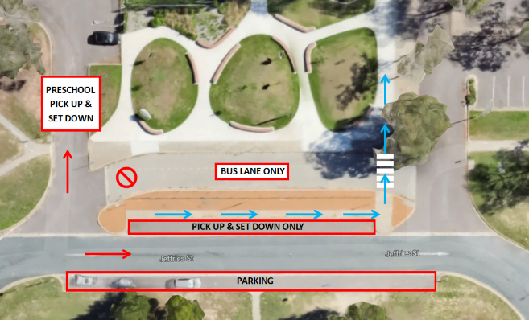  The second option for Pick up is the back gate located in the Northeast corner of the site. There is a carpark which entry and exit can be accessed from Castleton Crescent.  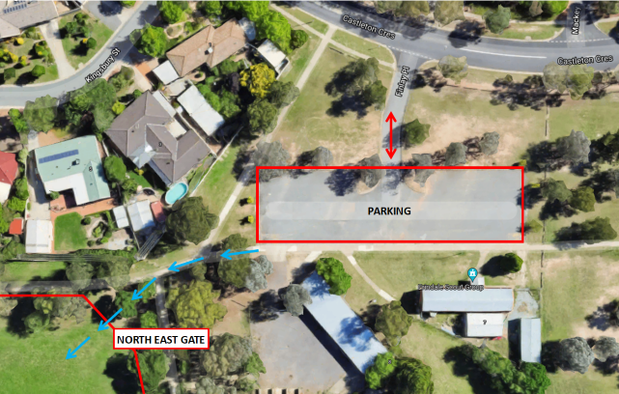  Preschool  Pick up and drop of for the preschool will occur at the front entrance gate of the preschool. Further information will be provided through the Storypark page.  Students will enter/ exit the school at either of the front side gates or the gate located in the Northeast Corner. See below diagram with yellow arrows.  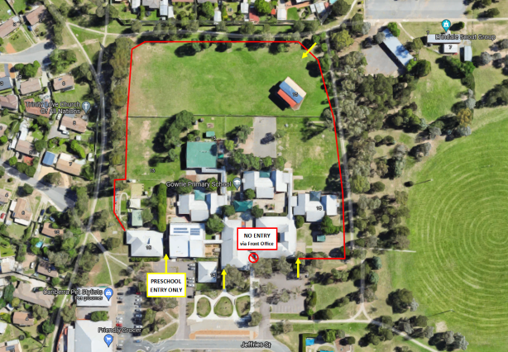
Hygiene routines | Staff, students and visitors will be requested to wash hands on arrival. The students will be instructed to wash hands frequently throughout the day. This will occur when entering and exiting Units and when transitioning from various in class activities. Hand soap will be fully stocked in all bathrooms.  Approved hand sanitiser will be available at all entry and exit points to all buildings and available in all teaching and learning spaces.
Teaching and learning | Gowrie Primary will operate in 4 separate cohorts/teams. There will be a P-2, 3-4, 5-6 and Brindabella team. Each team including students and staff will remain separate of each other. This will include break times and learning times.  Specialist subjects such as Japanese, Visual arts and Physical Education will no longer occur as specialist subjects. They will be taught within the class setting, where possible. Each teacher of these specialist subjects will be limited to one teaching team. This will minimise movement across cohorts.  Yumiko Dark P-2  Anel Vanzyl 3-4  Kirsty Noad 5-6  The school library will be closed. However, class sets of books relevant to study topics will be distributed to each class.  There will be no whole school events for the remainder of the year. This includes Gowrie Gathering, School Assemblies and Christmas Concerts.
Break times | The break times have been adjusted to support limited contact between students and staff.  Students will have access to the entire playground with only their immediate cohort/team of students. The below timetable sets out student breaks.  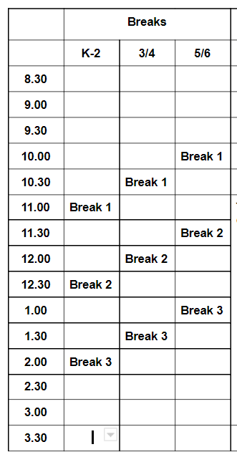
Before and After School Care | Pick up and drop off for out of school hour care is at the side gate. Parents and Carers will need to wait at the gate and not enter the school building.  Please see arrow below to indicate location.  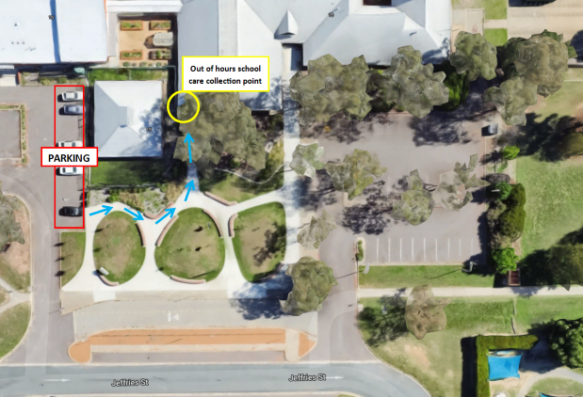
School canteens | The school canteen will remain closed for the remainder of the year.

We will continue to review and adjust these measures based on advice from ACT Health.
Remember, all adults and children aged 12 years and above are eligible for vaccination. If your child is eligible but not yet vaccinated, we encourage you to book them in by calling the COVID-19 vaccination line on 5124 7700 daily between 7am-7pm. Bookings can also be made with some GP clinics and pharmacies.
We understand that there has been considerable change and uncertainty for our students during the pandemic, and as we transition back to school. I’d remind you that you and your child can book an appointment with our Telehealth Support Service on 02 6205 1559 between 9.00am and 4.30pm weekdays. With the return to school, your child will also be able to organise face to face sessions with the school psychologist.
For more information about the return to schools, I’d recommend visiting the Education Directorate’s website.
You can keep up to date with the latest health information, advice and resources on the ACT’s COVID-19 website.
I would also like to take this opportunity to thank you for your support and understanding as we return to face-to-face schooling.
We look forward to welcoming all our students back at school.
Regards,
Simon Smith
Gowrie Primary School

